Mid Term
Q1.
The dataset contains missing values on column occupation and regionType.
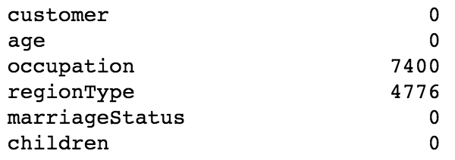
- occupation: This column missed 74% of overall data so it is purged.
- regionType: All missing values, together with the original ‘unknown’ are imputed with string ‘missing’. Meanwhile ‘r’ is transformed into ‘rural’, ‘s’ into ‘suburban’ and ‘t’ into town, so now the feature contains 4 clear categorical values, and get one-hot encoded.
- age: 30% of the values are zero. KNN imputation was tried here to impute invalid values according to its near neighbors, which had little impact on the overall performance, so this feature was purged.
- customer: id column, purged.
- creditCard: applied some mapping. ‘TRUE’, ‘t’ and ‘yes’ into 1, and ‘FALSE’, ‘f’, ‘no’ into 0.
- creditRating: label encoded into numeric values, the range of A-G is transformed into 7-1.
- children, smartPhone, homeOwner: simply encode True into 1 and False into 0.

Q2.
The problem here is a typical binary classification. And the features contain both numeric and categorical values. For this scenario, decision trees are worth a try, especially with bagging and boosting techniques to adaptively improve the performance. So the decision tree would be the first classifier of my choice. More specifically, grandient boosting is selected since it would be easier to customize the weight ourselves.
A 80-20 split was applied for train-test split, and a self implemented grid search was applied on the XGBoost implementation of the Gradient Boosting classifier.
Grid search generates the best gradient boosting forest with [] trees with binary [] loss, [] max tree depth, [] min child weight and a bunch of other detailed parameters. Due to the limit of computation resource, cross validation was not applied during grid search.

The choice of the other classifier came from the pearson correlation.
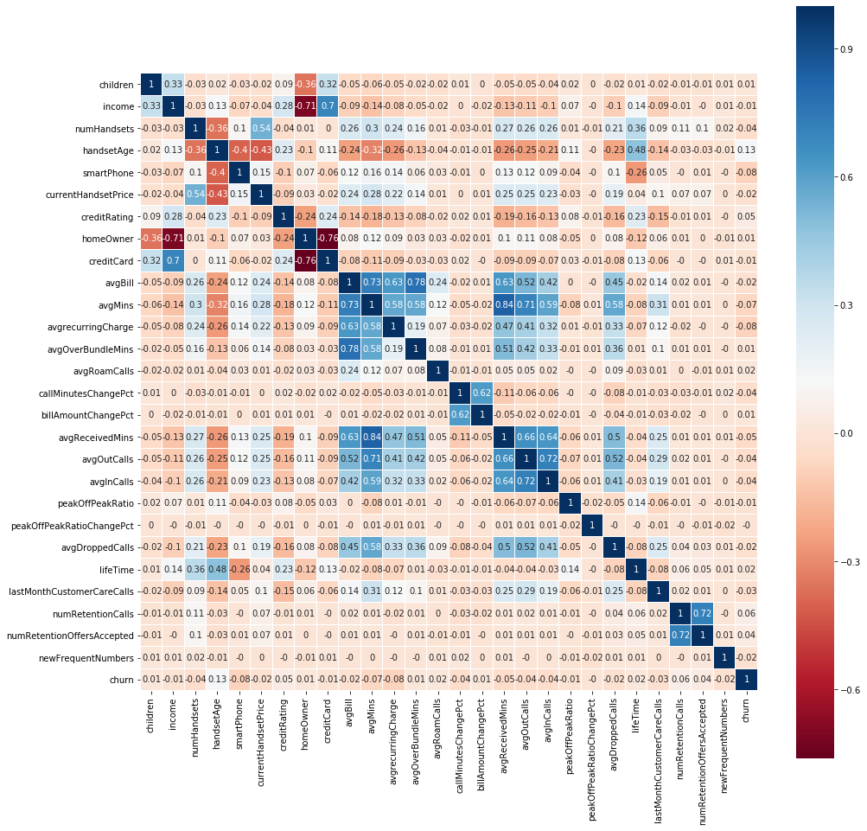

The target churn doesn’t seem to have a strong correlation with any of the features we have, indicating some strong nonlinear relationship between the target and independent variables. That’s why neural network is chosen here to model the mapping of inputs and outputs.
The architecture of the neural network applied for this problem involves the consideration of all the beneficial components discussed during lab3, with considerable amount of tuning and tinkering. The final structure looks like below.
[architecture]
which contains [] dense layers with [] neurons and ReLU activation, dropout layers with rate of [], and an output layer with sigmoid activation since it’s a binary classification. A binary cross entropy loss is applied here, together with an Adadelta optimizer that smartly finds the optimal gradient with a learning rate of [].

Q3.
The gradient boosting classifier outputs an accuracy of [] on the test set, and the confusion matrix is as below:
[confusion matrix]
[sensitivity, specificity]

The neural network in general outputs and accuracy of [] on the test set, with the confusion matrix as below:
[confusion matrix]
[sensitivity, specificity]

[comparison, preference]

Q4.
In order to optimize for the least cost, we need to customize the loss function of our model according to the given weights on different sections of the confusion matrix.
actual predicted | true | false
true | 0 | 700
false | 100 | 0
The Gradient Boosting classifier enables a customizable interface for a self defined loss function, which requires overriding the gradient and hessian returned for the objective interface enabled by XGBoost. So here, we multiply the given weights to the corresponding gradients to form our customized loss to form the updated gradient.
The updated model adopting this customized loss generates an accuracy of [], and the confusion matrix changes to:
[confusion matrix]

